***A Mini Project Synopsis on***

# E-LIBRARY MANAGEMENT SYSTEM

**S.E. – Computer Science and Engineering-Data Science**

**Submitted By**

**DEVANSH KOPRA - 21107013 KHUSHI KADAM - 21107031**

**SHRAVANI KULKARNI - 21107063 KRISH JASWAL - 21107039**

**Under The Guidance Of**

**PROF.VAIBHAV YAVALKAR**



**DEPARTMENT OF CSE-DATA SCIENCE**

A.P.SHAH INSTITUTE OF TECHNOLOGY

G.B. Road, Kasarvadavali, Thane (W), Mumbai-400615 UNIVERSITY OF MUMBAI

**Academic year: 2022-23**

# CERTIFICATE

This to certify that the Mini Project report on **E-LIBRARY MANAGEMENT SYSTEM** has been submitted by Devansh Kopra(21107013), Khushi Kadam(21107031), Shravani Kulkarni(21107063) and Krish Jaswal(21107039) who are a Bonafede students of A. P. Shah Institute of Technology, Thane, Mumbai, as a partial fulfillment of the requirement for the degree in **Computer Science and Engineering(Data Science)**, during the academic

year **2022-2023** in the satisfactory manner as per the curriculum laid down by University of

Mumbai.

Prof. Vaibhav Yavalkar Guide

Prof. Anagha Aher Dr. Uttam D.Kolekar Head Department of CSE-Data Science Principal

External Examiner(s) 1.

2.

Place: A. P. Shah Institute of Technology, Thane Date :

**TABLE OF CONTENTS**

1. Introduction. 1
   1. Purpose 1
   2. Objectives. 1
   3. Scope 2
2. Problem Definition… 3
3. Proposed System… 4
   1. Features and Functionality 4
4. Project Outcomes. 5
5. Software Requirements 6
6. Project Design 7
7. Project Scheduling 12
8. Conclusion 14

**Acknowledgement**

This project would not have come to fruition without the invaluable help of our guide Prof. Vaibhav Yawalkar. Expressing gratitude towards our HoD, Prof. Anagha Aher, and the Department of Computer Science and Engineering-Data Science for providing us with the opportunity as well as the support required to pursue this project. We would also like to thank our teacher Prof. Poonam Pangarkar and Prof. Rajashri Chaudhari who gave us her valuable suggestions and ideas when we were in need of them. We would also like to thankour peers for their helpful suggestions.

# Chapter 1

## Introduction:

Library Management System is an application which refers to library systems which are generally small or medium in size. It will assist the librarian before the shortage of books while they can know the details of the number of currently available in the library according to the author by accessing the system. A student can view the details of the book issued by them, and the system will notify the students about the last date of submission of books. If user’s position is admin, the user is able to generate different kinds of reports like lists of students registered, list of books, issue and return reports. All these modules are able to help librarian to manage the library**.**

## Purpose:

* + - The purpose of this project is to provide a user-friendly environment to maintain the details of books and library members.
    - To maintain easy circulation system using computers and to provide different reports.
    - Improved user service through greater access to accurate information.
    - Due to computerized information it reduces the use of paper work such as lost file, damaged file and time consumption.

## Objective:

Improvement in control and performance the system is developed to cope up with the current issues and problems of library. The system can add user, validate user and is also bug free. Save cost after computerized system is implemented less human force will be required to maintain the library thus reducing the overall cost to same time. Librarian is able to search by using few clicks of mouse and few search keywords thus saving his valuable time. Option of online notice board Librarian will be able to providea detailed description of workshops going in the college as well as in nearby colleges Lecture Notes Teacher have a facility to upload lectures notes in a pdf file having size not more than 10mb.

Pg 1

## Scope:

* + - The document only covers the requirement specifications for the Library Management System. This document does not provide any other information about Library Management System.
    - This document does not provide any other references to the other component of the Library Management System.
    - All the dependencies are also included in this document.
    - The system is developed to cope up with the current issues and problems of library.
    - This project is basically updating the manual library system into a software based application so that the user can get details of their account availability of books etc.
    - After computerized system is implemented less human force will be required to maintain the library thus reducing the overall cost.

Pg 2

# Chapter 2

## Problem Definition:

The problem occurred before having computerized system includes: Filelost when computerized system is not implemented, file is always lost because of human environment. Sometimes due to some human error there may be a loss of records. File damaged when a computerized system is not there, file is always lost due to some accident like spilling of water by some member on file accidentally. Besides natural disaster like floods or fires may also damage the files which is difficult to search record. When there is no computerized system there is always a difficulty in searching of records. After the number of records become large the spacefor physical storage of file and records also increases if no computerized system is implemented.

Pg 3

# Chapter 3

## Proposed System:

The proposed Online Library Management System project will help the students and librarian to maintain the details of the library. It is used by librarian to manage the library, record various transactions like issue of books, addition of new books, addition of new students etc. Books and student maintenance modules are also included in this system which would keep track of the students using the library and also a detailed description about the books which a library contains. At the time of issue of a book, the student will get assisted by the system about different authors of a similar book so that they can get the best available book from the library.

* 1. Features and Functionality:
     + Integration of all records of students
     + Manage the records systematically
     + It can track any information online
     + Manage all information online
     + Easy to maintain records
     + It leads to fast book entry

The demand for Library Automation Software in India is increasing day by day with the advancement of the system. As we all are living in the digital age, everyone prefers quick and accurate service. Almost all schools and colleges prefer the Library Management System due to the organized and systematic management of the database. College Library software helps the students to prepare their projects easily and in less time. It also helps in preparing notes and assignments.

Library Management System helps the student in better learning by providing quick access to the library systems. With Advance Library Software they can easily find books, catalogues, magazines of their interest. The Library is a great place to study and make notes which ultimately help in scoring a good score.

Pg 4

**Project Outcomes:**

# Chapter 4

Project outcomes are the changes that occur as a result of your actions. These typically involve improvements for a product or service. When designing a project, its important to know what your project outcomes are so you have a way of measuring your success and understand what your overall goal is. They are also valuable for businesses because they help create deliverables to meet their purpose and goal.

* + - * Save Time:

Librarian is able to search record by using few clicks of mouse and few search keywords thus saving his valuable time.

* + - * Improvement in control and performance:

The system is developed to cope up with the current issues and problems of library. The system can add user, validate user and it is also bug free.

* + - * Save Cost:

After computerized system is implemented less human force will be required to maintain the library thus reducing the overall cost.

Pg 5

# Chapter 5

## Software Requirements:

Software Requirement Specification (SRS) Format as name suggests, is complete specification and description of requirements of software that needs to be fulfilled for successful development of software system. These requirements can be functional as well as non-functional depending upon type of requirement. This is description of features and functionalities of the target system. Requirements convey the expectations of users from the software product. It is the responsibility of system analyst to document the requirements in technical language so that they can be comprehended and useful by the software development team.

The software and technology stack used in development of E-Library Management System are:

* + - * The JDK includes tool useful for developing and testing programs written in the Java programming language and running on the Java platform.
      * NetBeans - Network+ Java Beans

NetBeans is an integrated development environment for Java. NetBeans IDE version -14

* + - * MySQL is a Database Management System,
      * MySQL, the most popular Open Source SQL database management system, is developed, distributed, and supported by Oracle Corporation.

MySQL version-14

* + - * Database done in MySQL
      * Front End: NetBeans IDE
      * Back End: MySQL

Pg 6

# Chapter 6

## Project Designing :

1. **Login Page :**

### This is the very first page of the Library Management System.

* + The student needs to enter his / her **CORRECT USERNAME AND PASSWORD** inorder to access the system.

### If the user has forgotten his login credentials , a **FORGOT PASSWORD** option has also been made available for the user’s ease.

* + Below , a direct login access for the Librarian / Admin is given which sends them to the Homepage upon insertion of correct username and password.

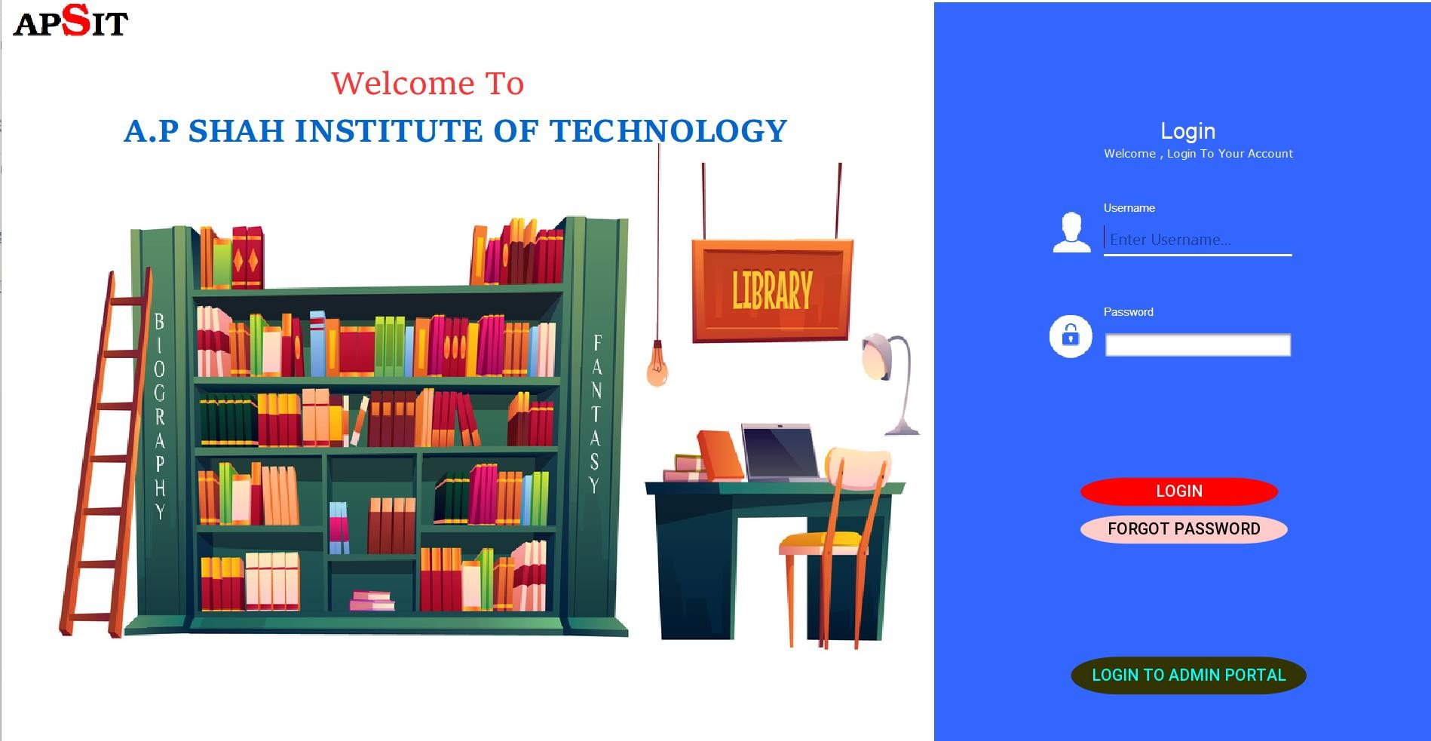

Pg 7

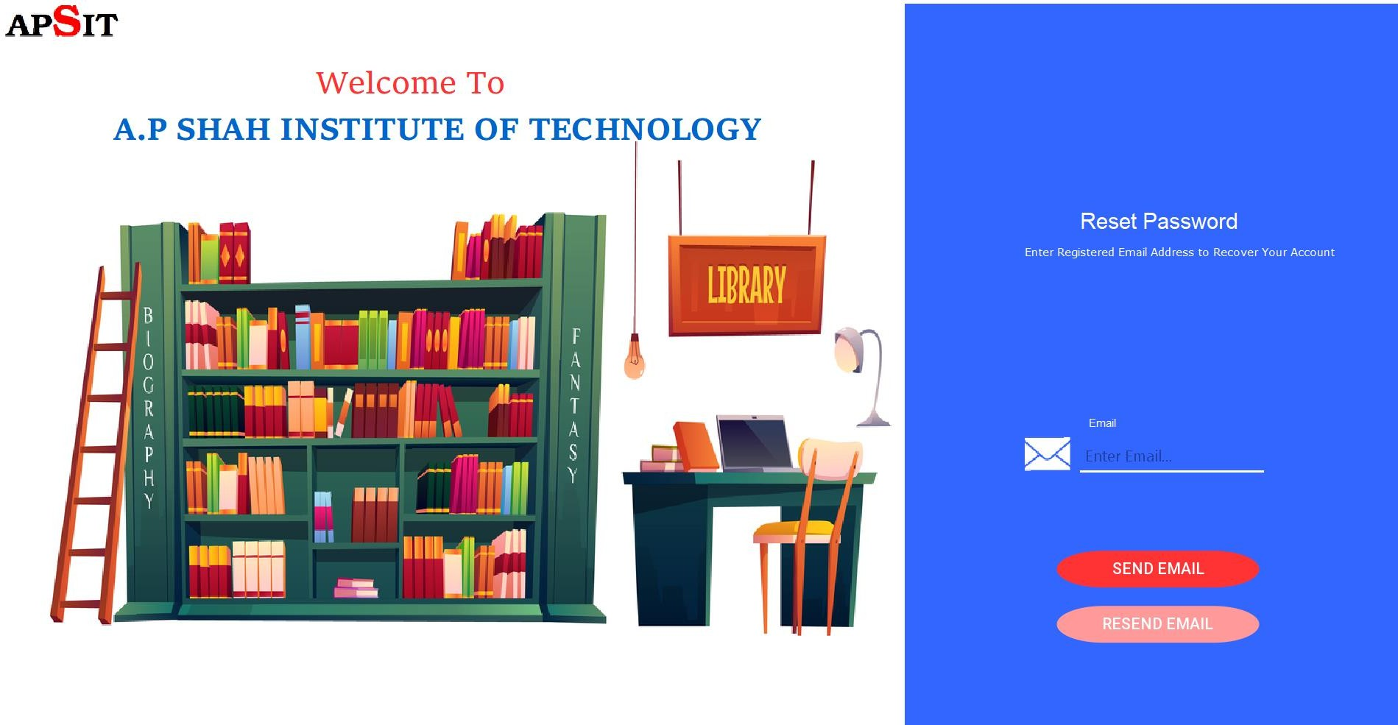

## Forgot Password :

### If a user has forgot his correct Login credentials , the forgot password page helps them to **recover their account** and change the password for further access.

Pg 8

## Admin’s Homepage :

### This is the Homepage where a Librarian works his way mainly through the Library Management System.

* + One can find modules such as **Add new Student** , **Manage Books , Issue Books , Issue Books To Teacher , View Registered Students.**
  + The **logout button** takes the user back to the Login page.

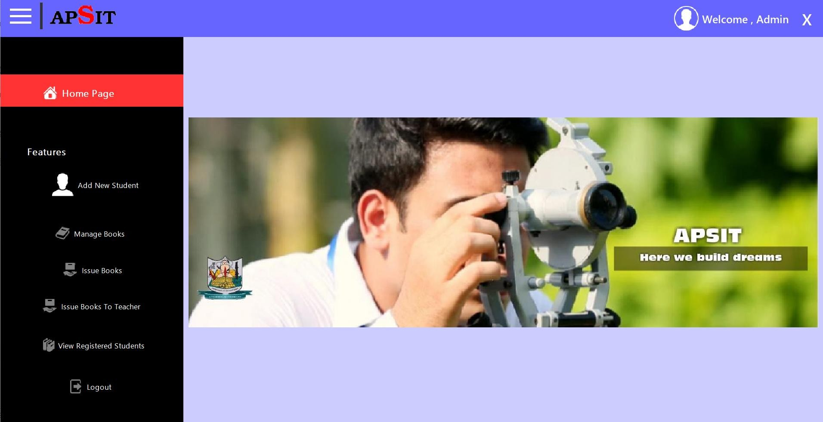

Pg 9

## View My Profile :

### Here , the user can see his / her personal information which is entered in the database.

* + The **EDIT PROFILE** button redirects the user to the edit profile page where the necessary changes can be done according to the user’s wish.

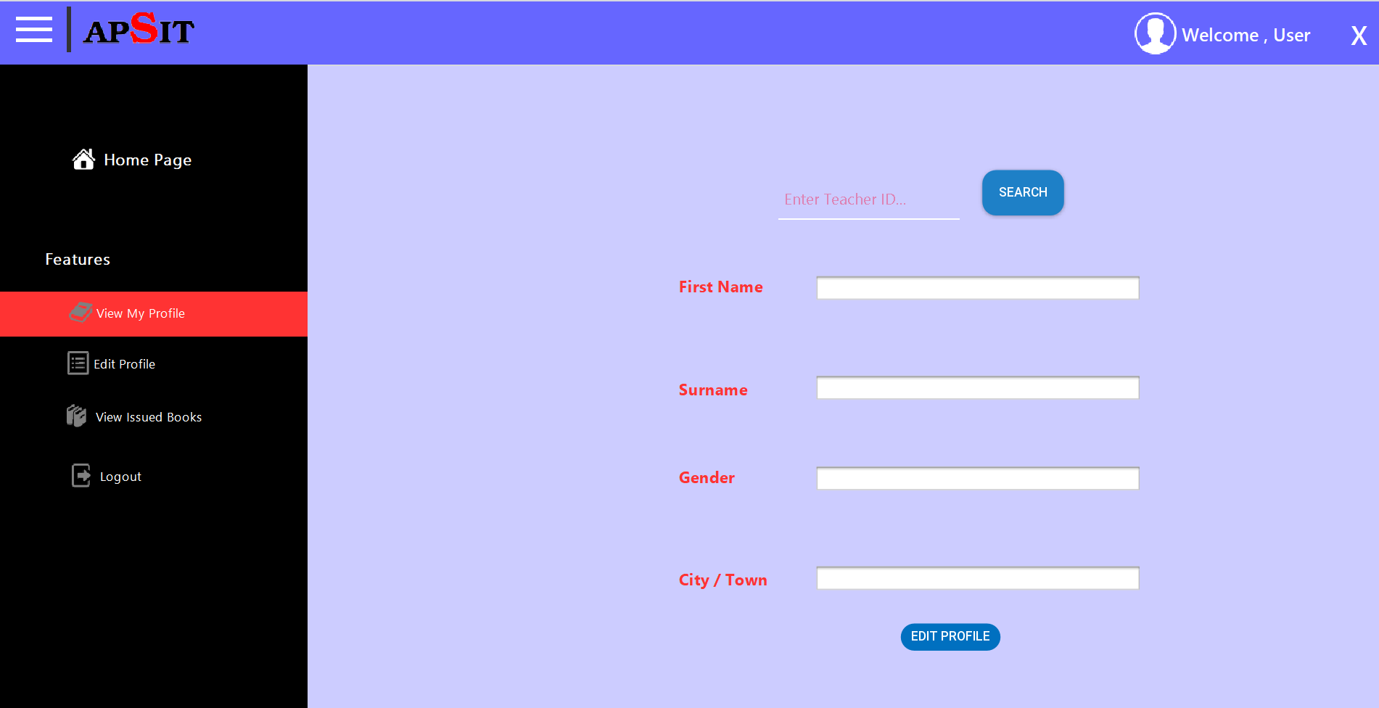

Pg 10

## Edit Profile :

Edit Profile modules helps the user to **update his / her data on the system automatically.**

Fields such as **First name , surname , email address , email display option , city/Town can be edited** according to the user’s choice at his /her own leisure time.

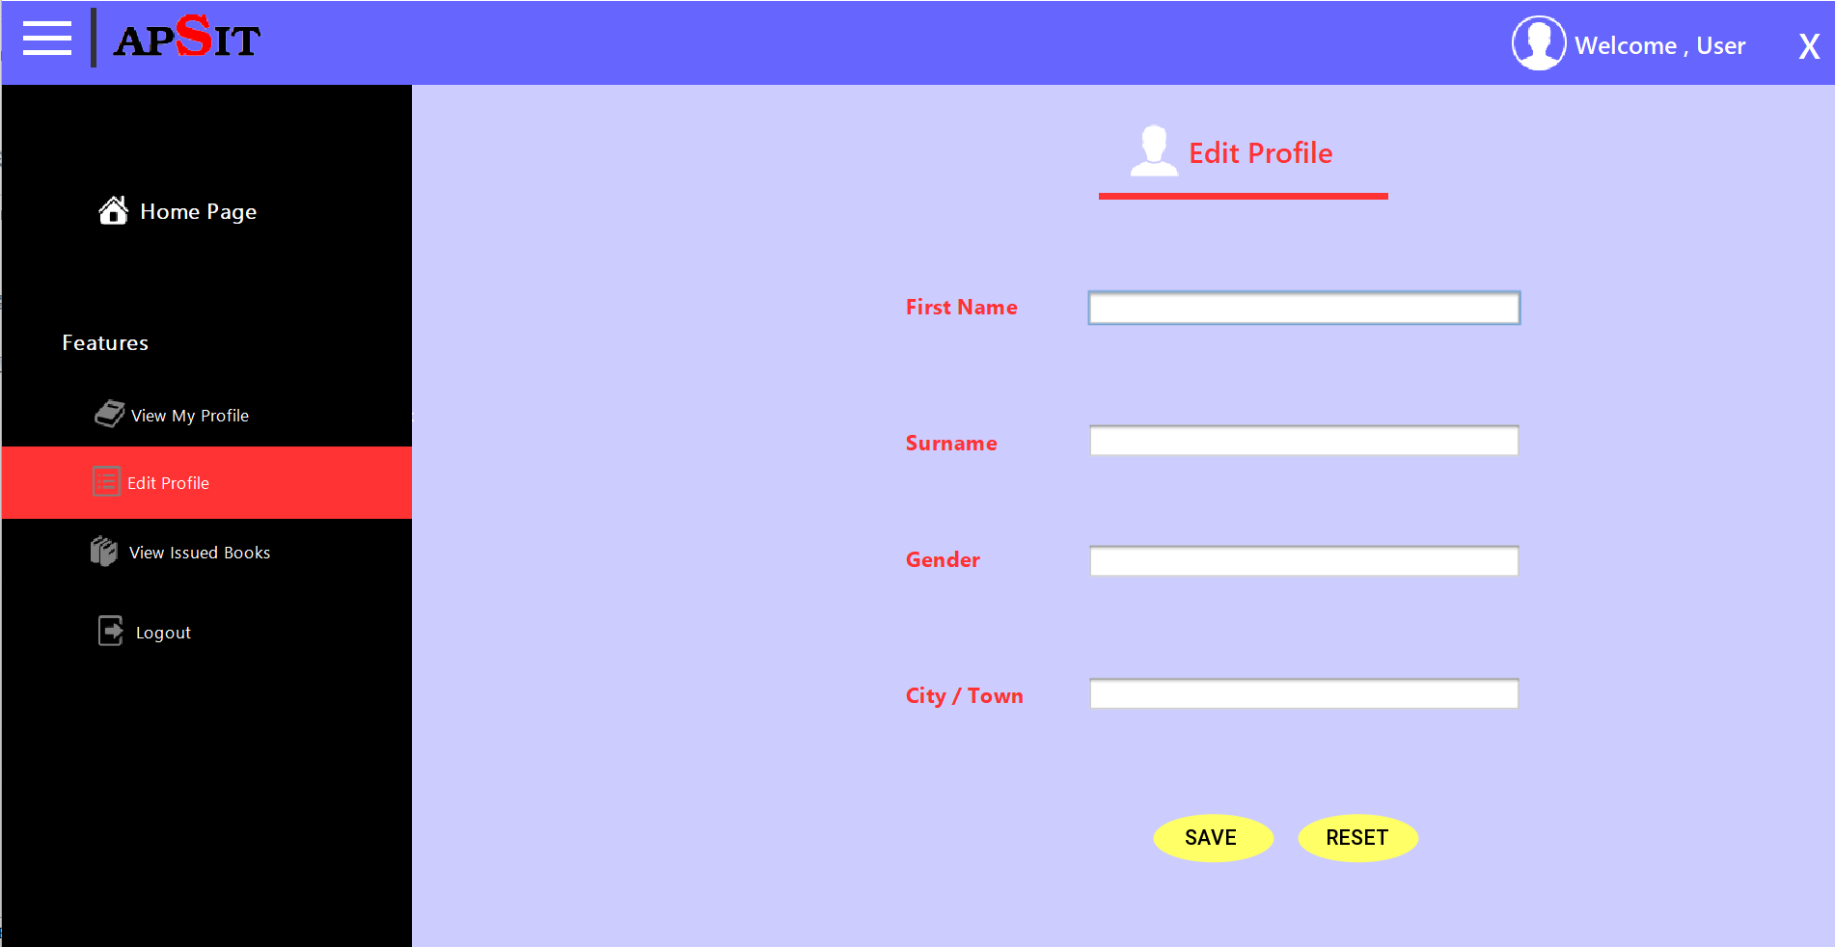

Pg 11

# Chapter 7

## Project Scheduling:

### A schedule in your project’s time table actually consists of sequenced activitiesand milestones that are needed to be delivered under a given period of time.

Project schedule simply means a mechanism that is used to communicate and know about that tasks are needed and has to be done or performed and which organizational resources will be given or allocated to these tasks and in what time duration or time frame work is needed to be performed. Effective project scheduling leads to success of project, reduced cost, and increased customer satisfaction. Scheduling in project management means to list out activities, deliverables, and milestones within a project that are delivered. It contains more notes than your average weekly planner notes. The most common and important form of project schedule is Gantt chart.

**What is Gantt Chart?**

A Gantt chart is a type of bar chart that illustrates a project schedule and shows the dependency relationships between activities and current schedule status.

In simpler words, Gantt charts are a visual view of tasks displayed against time. They represent critical information such as who is assigned to what, duration of tasks, and overlapping activities in a project. All in all, Gantt charts are the perfect allies for planning, scheduling, and managing a project.

A Gantt Chart, in its simplest form, is a timeline that illustrates how the project will progress during the project management process. And the timeline view offered by Gantt Charts is proven quite useful for planning and scheduling projects. It helps project managers and project teams to assess how long a project should take, determine the resources needed, understand the dependencies between tasks, and plan the order in which each task will be completed if the whole project is to deliver on time.

As the project moves forward, a Gantt chart adjusts simultaneously, displaying an up- to-date project schedule to keep everyone (teams, clients, and stakeholders) informed of the progress. In addition to this, Gantt charts replace meetings and enhance other status updates. They make it easy for teams to understand task progress and talk about the problems they may encounter. In all, using a Gantt chart or a Gantt chart tool is useful during project management because it allows you to picture your project against the time frame it needs to be done in.

Pg 12

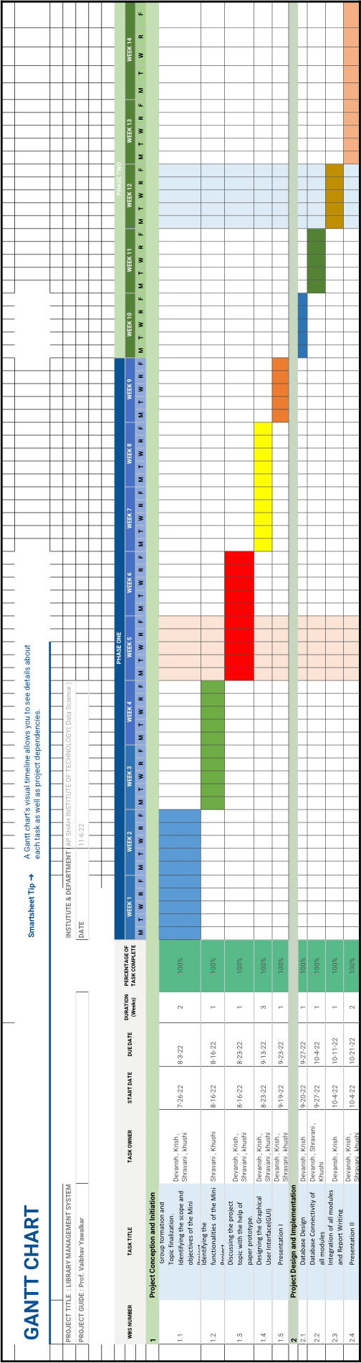

# Chapter 8

## Conclusion:

This website provides a computerized version of library management system which will benefit the students as well as the staff of the library. It makes entire process online where student can search books, staff can generate reports and do book transactions. It also has a facility for student login where student can login and can see status of books issued as well request for book or give some suggestions. It has a facility of teacher’s login where teachers can add lectures notes and also give necessary suggestion to library and also add info about workshops or events happening in our college or nearby college in the online notice board.

There is a future scope of this facility that many more features such as online lectures video tutorials can be added by teachers as well as online assignments submission facility, a feature of group chat where students can discuss various issues of engineering can be added to this project thus making it more interactive more user friendly and project which fulfills each user need in the best way possible.

Pg 14

# References:-

1. Studentsproject.live
2. nevonprojects.com
3. stackoverflow.com
4. <https://www.youtube.com/watch?v=frafcK6fhdQ>
5. <https://www.youtube.com/watch?v=NvlOv0DSETA>
6. <https://www.youtube.com/watch?v=FjQ0uWyXTuo>

Pg 15